**EXPT NO : 2 A python program to implement simple**

**DATE:30/08/2024 Regression using Least Square Method**

**AIM:**

To write a python program to implement Simple linear regression using Least Square Method.

**PROCEDURE:**

Implementing Simple linear regression using Least Square method using the headbrain dataset involve the following steps:

**Step 1: Import Necessary Libraries**

First, import the libraries that are essential for data manipulation, visualization, and model building.

import pandas as pd import matplotlib.pyplot as plt import numpy as np

**Step 2: Load the Iris Dataset** The HeadBrain dataset can be loaded. data = pd.read_csv('/content/headbrain.csv')

**Step 3: Data Preprocessing**

Ensure the data is clean and ready for modeling. Since the Iris dataset is clean, minimal preprocessing is needed.

x,y=np.array(list(data['Head Size(cm^3)'])),np.array(list(data['Brain Weight(grams)'])) print(x[:5],y[:5])

**OUTPUT :**



**Step 4 :Compute the Least Squares Solution**

Apply the least squares formula to find the regression coefficients. def get_line(x,y): x_m,y_m = np.mean(x), np.mean(y) print(x_m,y_m) x_d,y_d=x-x_m,y-y_m m = np.sum(x_d*y_d)/np.sum(x_d**2) c = y_m - (m*x_m) print(m, c) return lambda x : m*x+c

lin=get_line(x,y)

**OUTPUT :**



**Step 5 : Make Predictions**

Use the model to make predictions based on the independent variable. **def get_error(line_fuc, x, y):**

**y_m = np.mean(y) y_pred = np.array([line_fuc(_) for _ in x])**

**ss_t = np.sum((y-y_m)**2) ss_r = np.sum((y-y_pred)**2) return 1-(ss_r/ss_t) get_error(lin, x, y)**

**from sklearn.linear_model import LinearRegression x = x.reshape((len(x),1))**

**reg=LinearRegression() reg=reg.fit(x, y) print(reg.score(x, y))**

**OUTPUT :**





**Step 6 :Visualize the Results**

Plot the original data points and the fitted regression line.

x=np.linspace(np.min(x)-100,np.max(x)+100,1000) y=np.array([lin(x)for x in x]) plt.plot(x, y, color='red', label='Regression line') plt.scatter(x, y, color='green', label='Scatter plot') plt.xlabel('Head Size(cm^3)')

plt.ylabel('Brain Weight(grams)') plt.legend() plt.show()

**OUTPUT :**

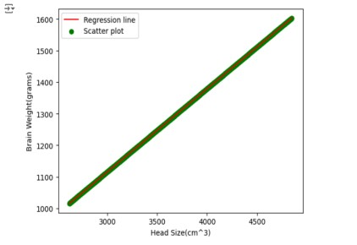

**RESULT:**

This step-by-step process will help us to implement least square regression models using the HeadBrain dataset and analyze their performance.